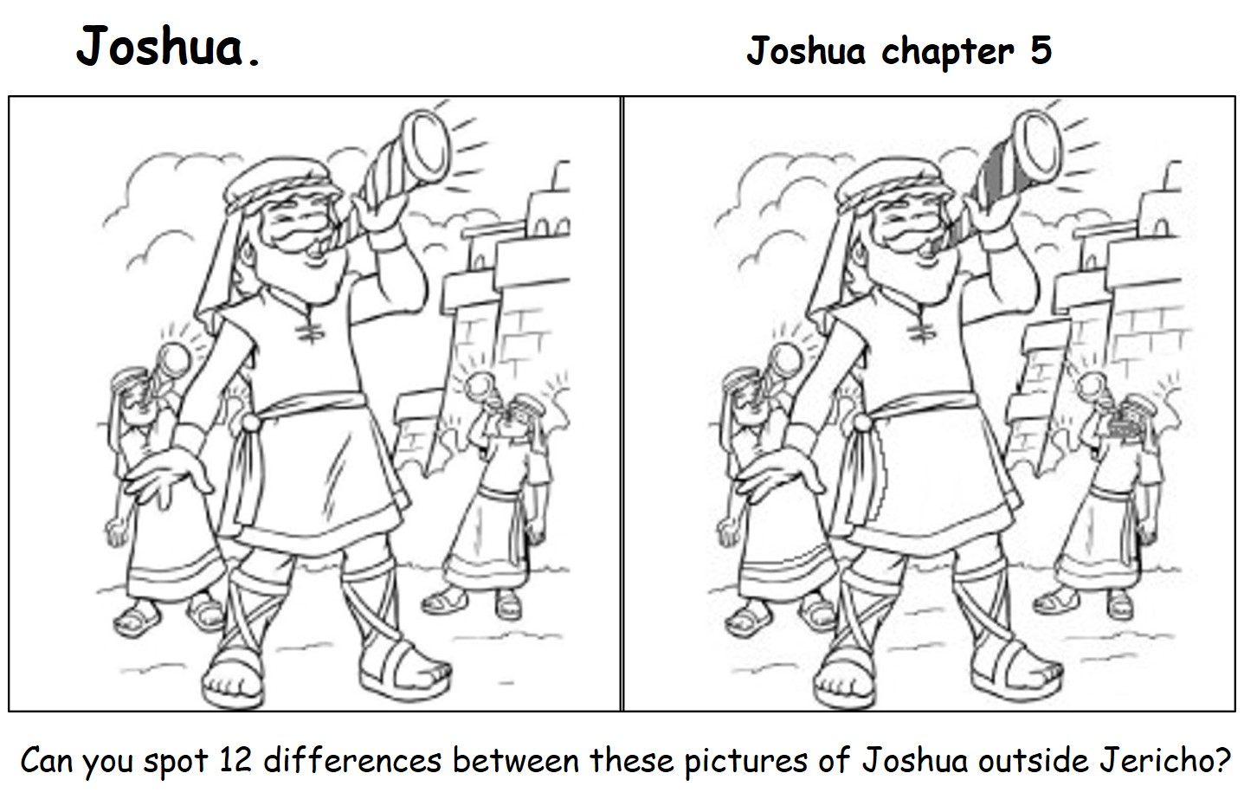
Original image http://getdrawings.com/joshua-coloring-pages

