Moses and the Burning Bush – Burning Bush Craft

In this activity you will need:
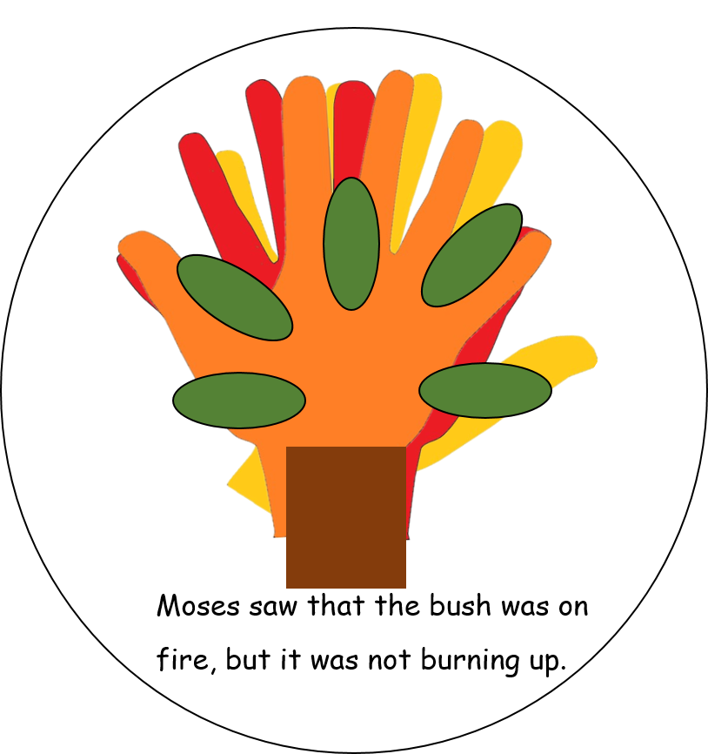
- Your hand
- A pencil
- Some sheets of coloured paper
- A disposable paper plate
- Some coloured crayons or pens
- Some paper glue
- A pair of scissors
- A clever mum or dad to help you with the cutting out and to adapt the instructions if you haven’t all the materials.

- Firstly, draw around your hand 3 or 4 times on pieces of coloured paper. If you have some red, yellow and orange paper these would be good to use, but if you haven’t, try and find some bright magazine pictures (that you don’t need).
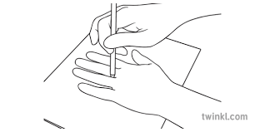

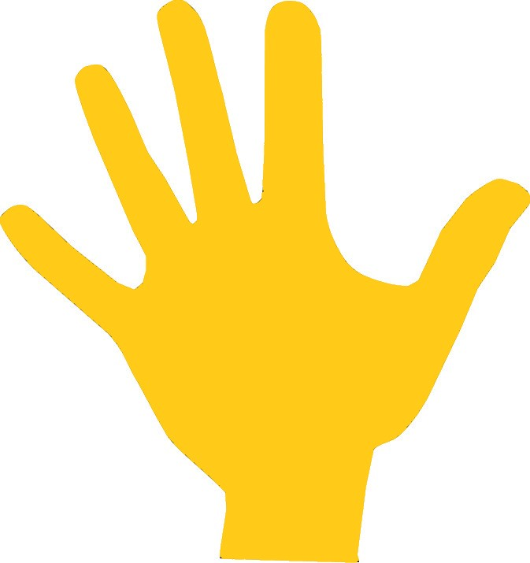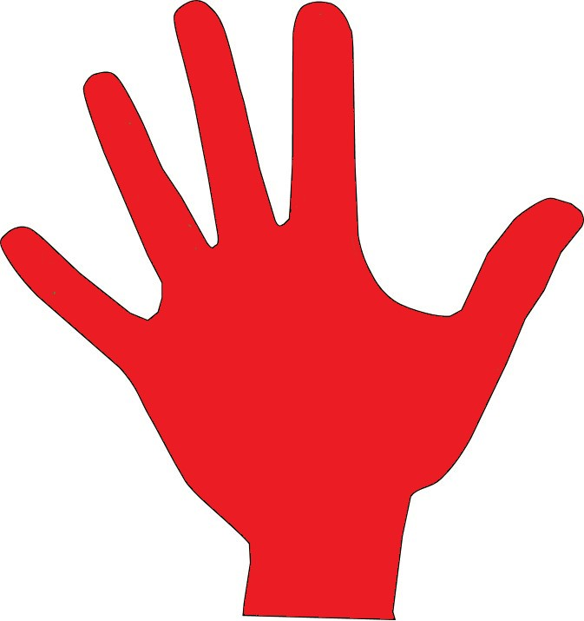
- Next, if you have used white paper colour the hands with bright orange, red and yellow crayons or pencils. You can use more than one colour on the same hand.

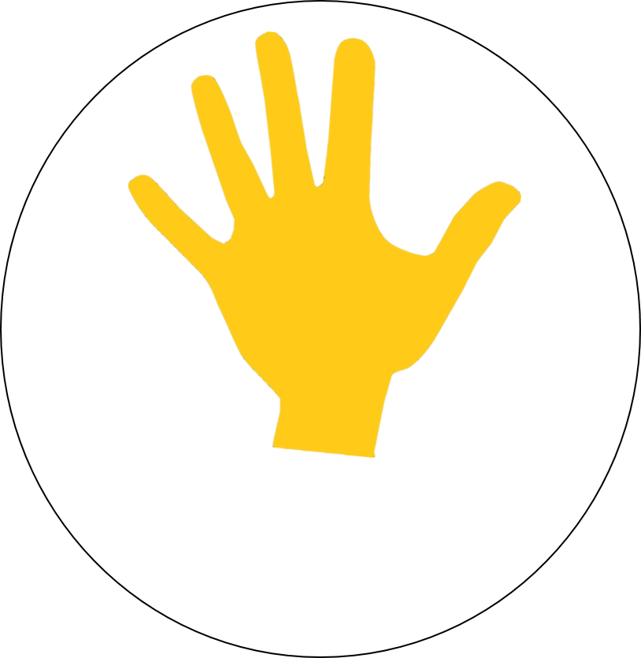

- Now cut out each of the hands, get mum or dad to help you if it is difficult.

- Stick one of the hands just above the middle of the paper plate.

- Now stick the other hands on top of the first hand.

- Next either cut out a rectangle approximately 4cm x 6cm from brown or black paper or from a dark picture in a magazine. (or you could colour a piece of white paper)

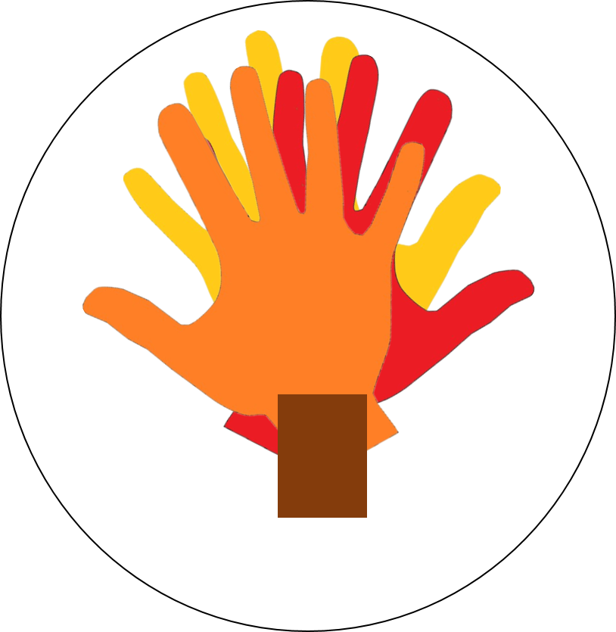
- Stick the rectangle on top of the hands so it looks like the stem of the bush.

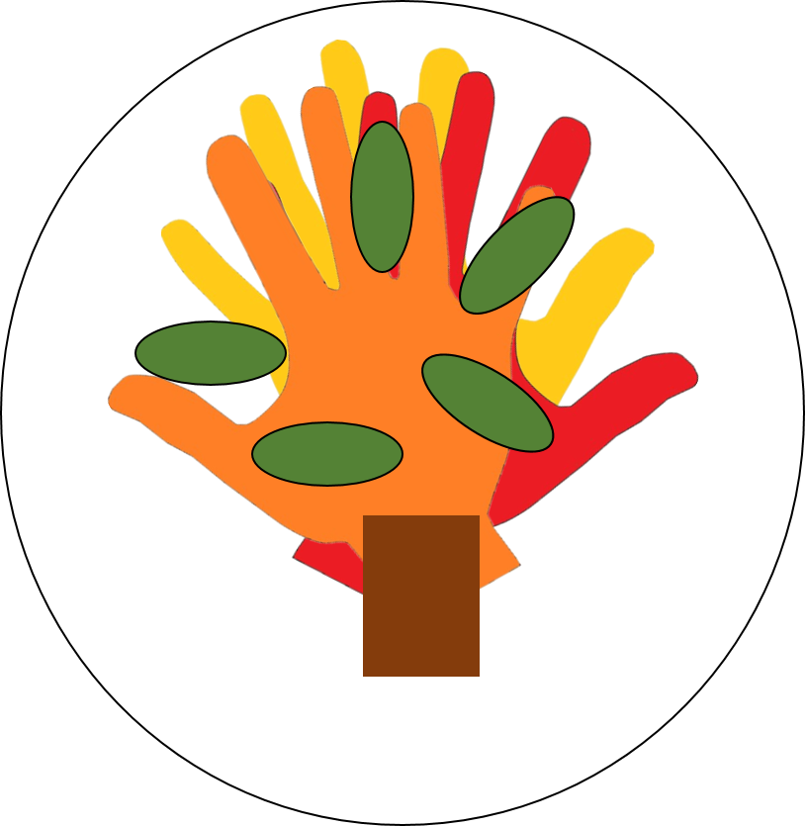

- Cut some petal shapes out of green paper and stick them onto the burning bush.
- Finally cut out the text box below and stick it on the base of the plate.
Moses saw that the bush was on fire, but it was not burning up.

The burning bush reminds us that God is everlasting and His promises are always kept.

