Jesus heals 10 lepers – Word Ladder Activity
In this activity, you have to get from the top step of the ladder to the bottom step, changing one letter each time to make a new word.
The people hated the Lepers but Jesus loved them.
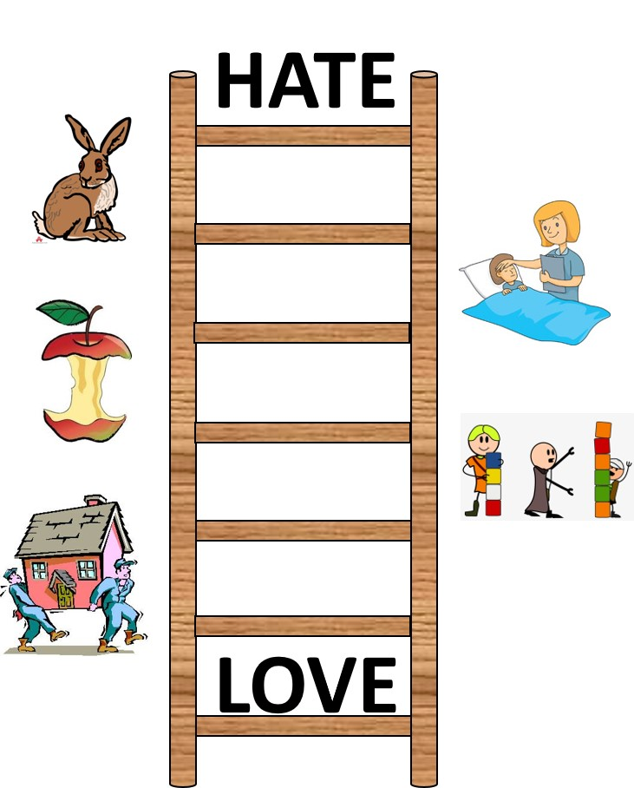
There are some picture clues to help you with the words.

