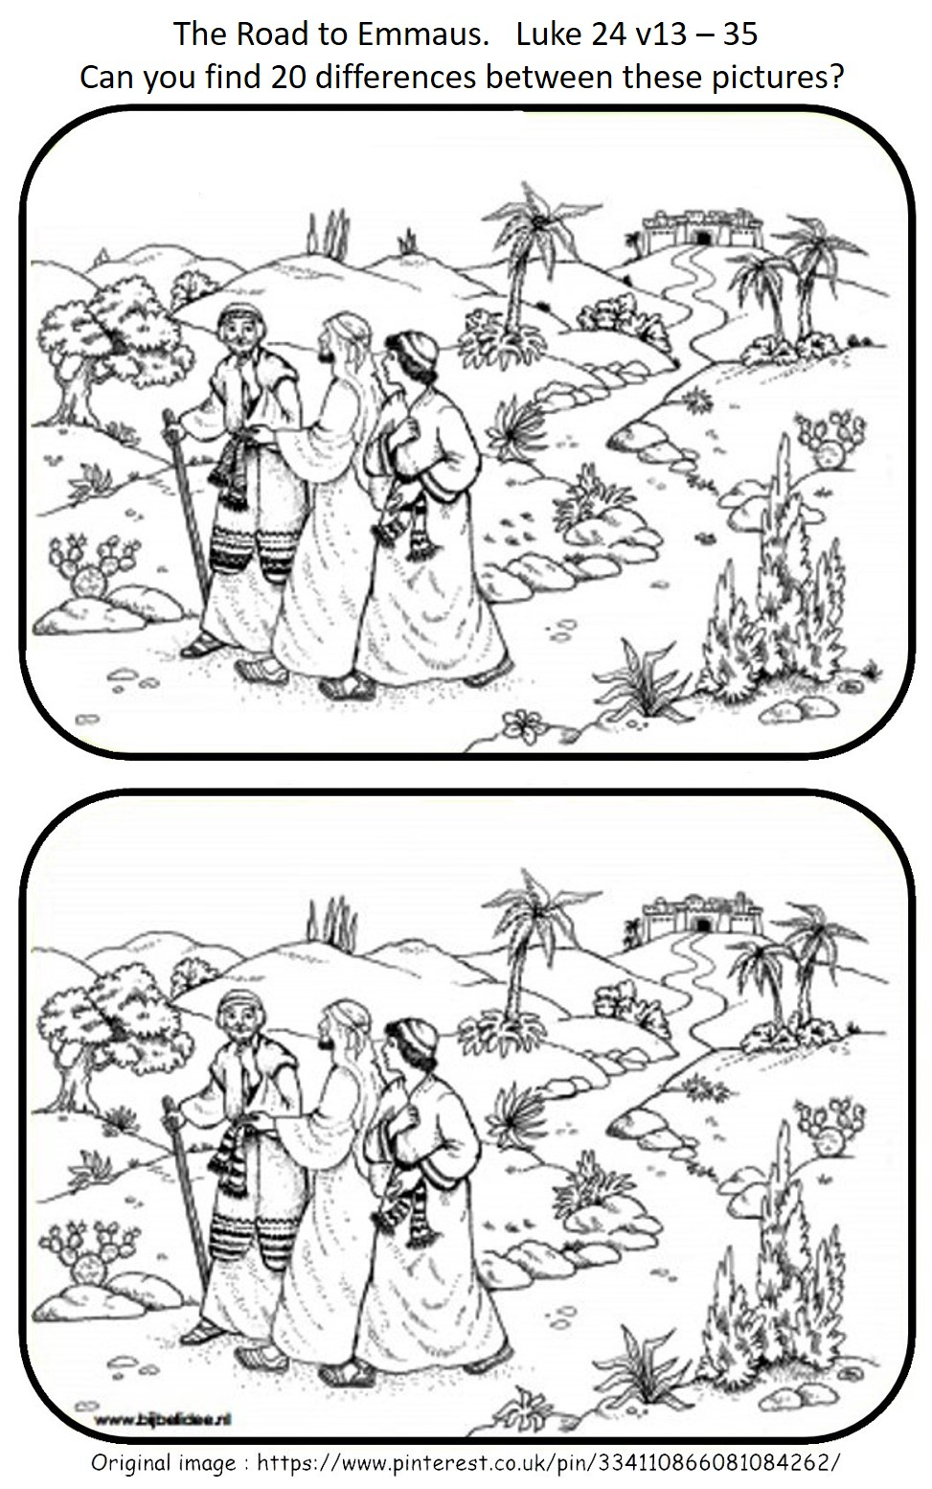

ANSWERS

