Jesus heals a blind man – face craft activity

In this activity you will need:
- An A4 piece of thin card or paper
- Pair of scissors
- Sellotape or glue stick
- Colouring pens / crayons / pencils
- A clever mum or dad to help you with the cutting and to adapt the instructions if you need help.
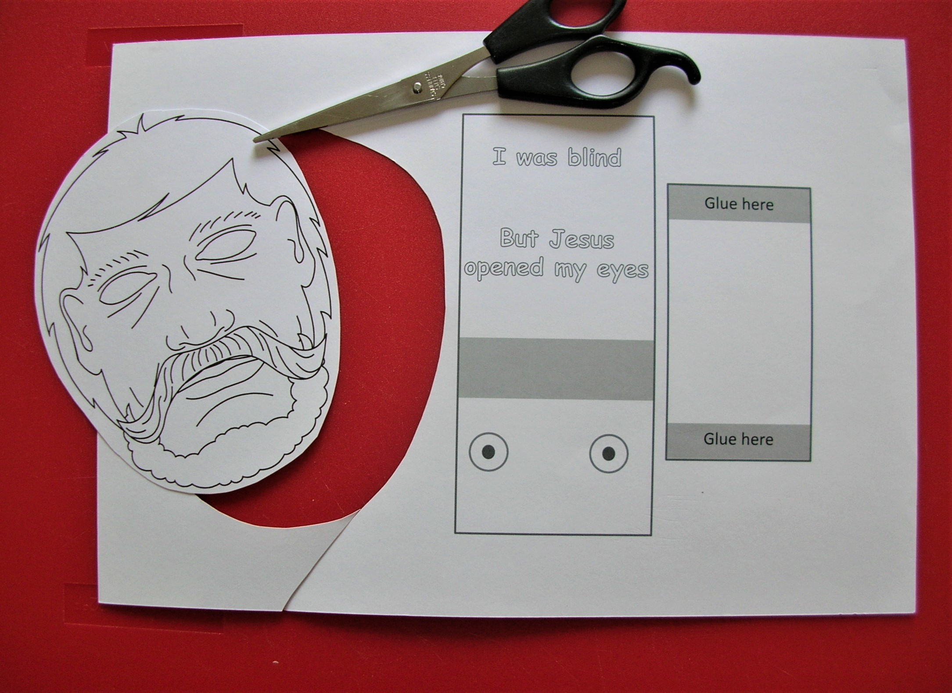
- Firstly, print out your activity card and cut out the face. If you are not good at cutting, cut out an oval shape – that’s what I did.
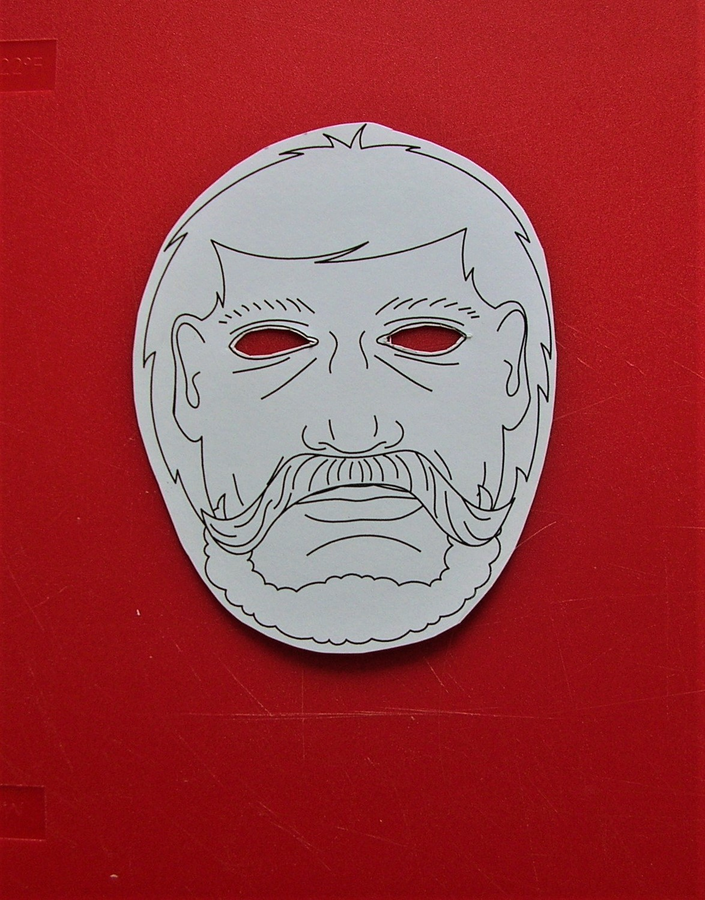

- Now get mum or dad to help you cut out the eye holes.

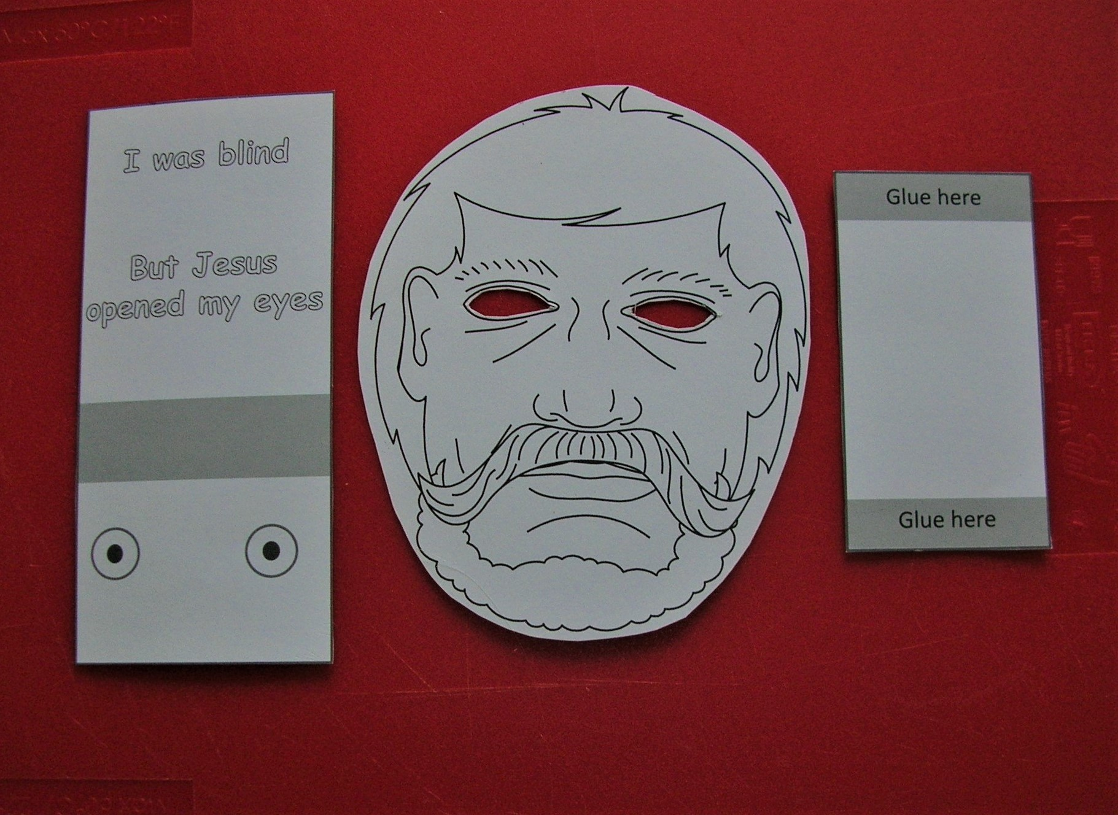
- Now cut out the other two shapes on your card

- Now take the small rectangle and put glue into the shaded area.
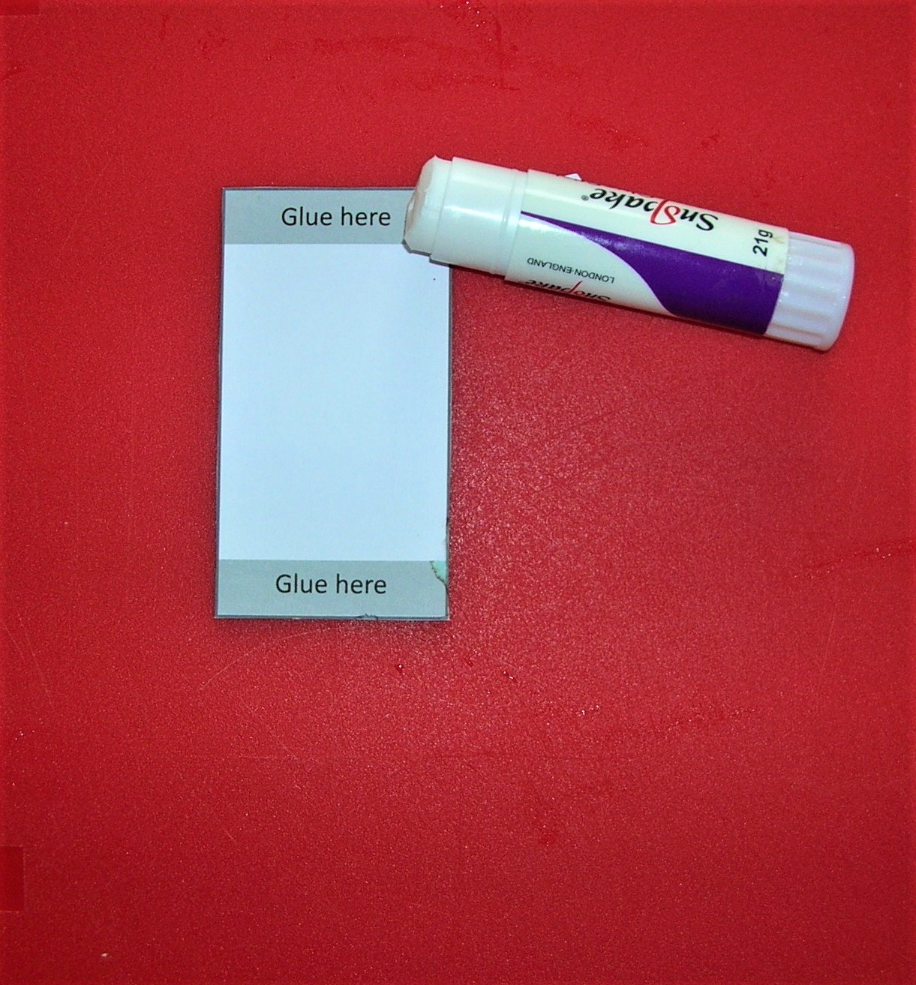
If you are using sellotape the tape should cover the grey area and overlap the outside of the rectangle.
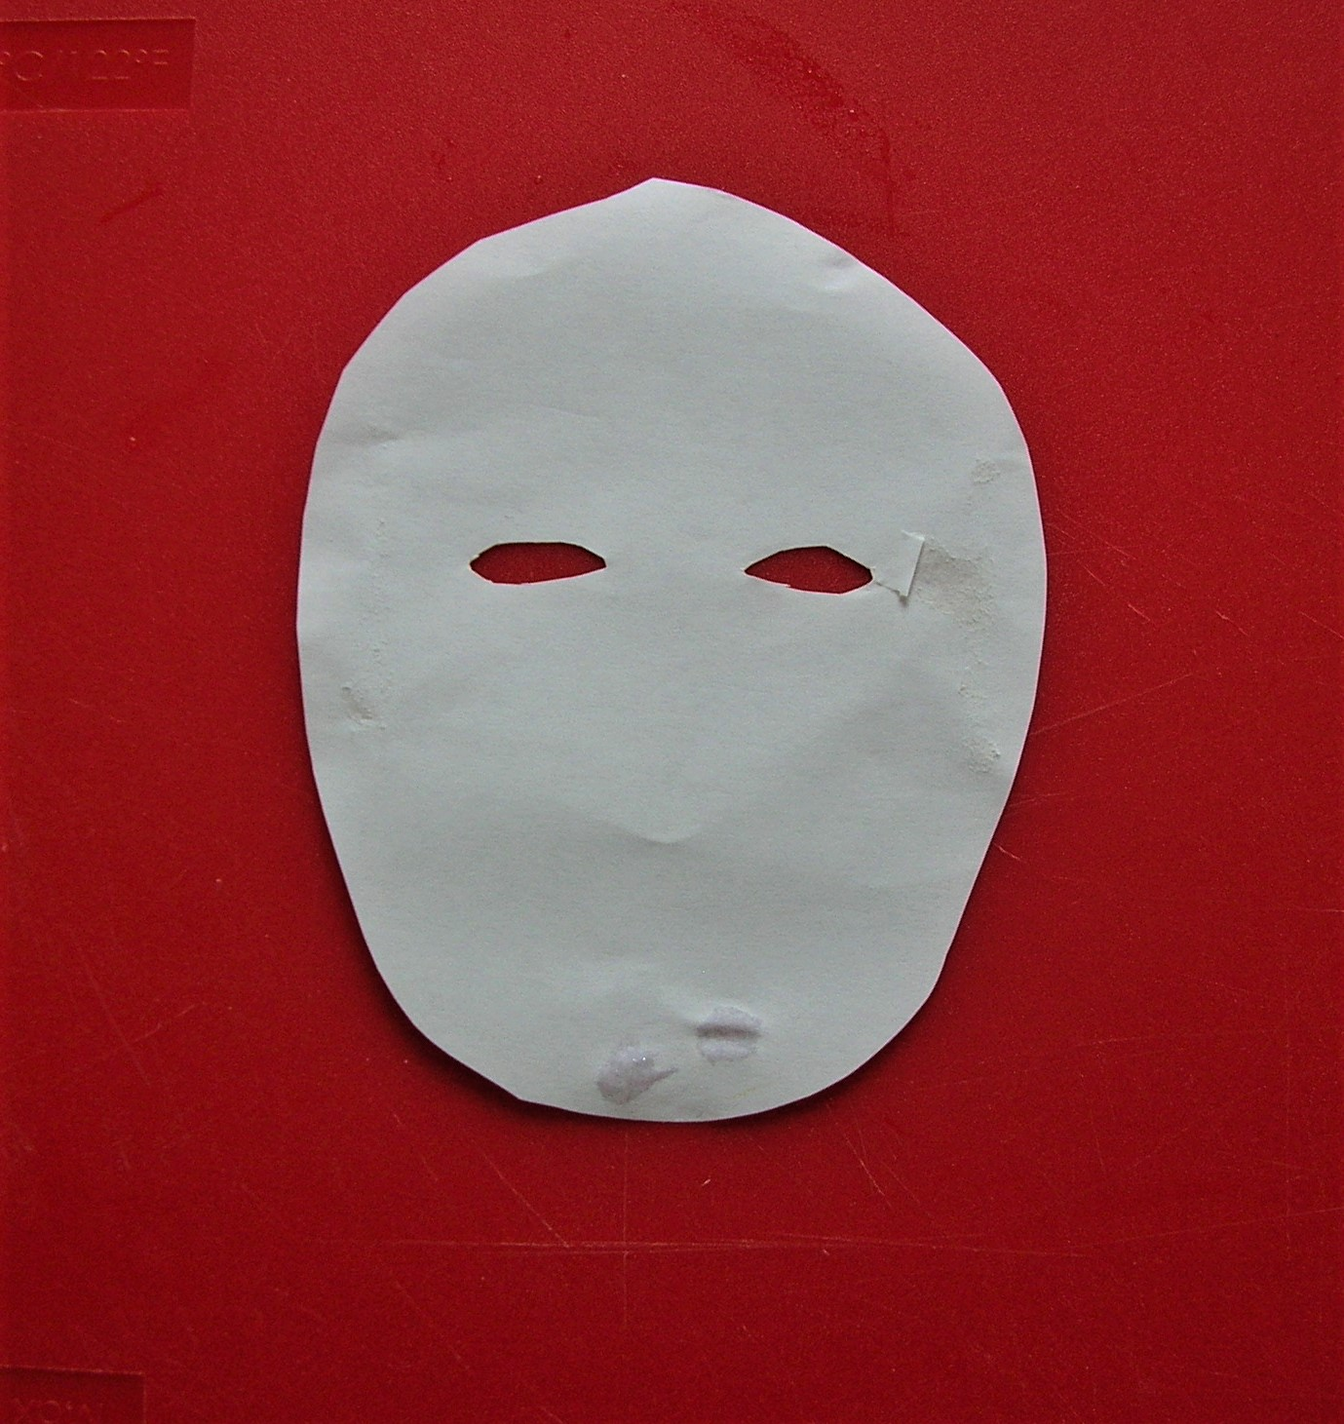

- Next, turn over the face cut out so that it is facing downwards.

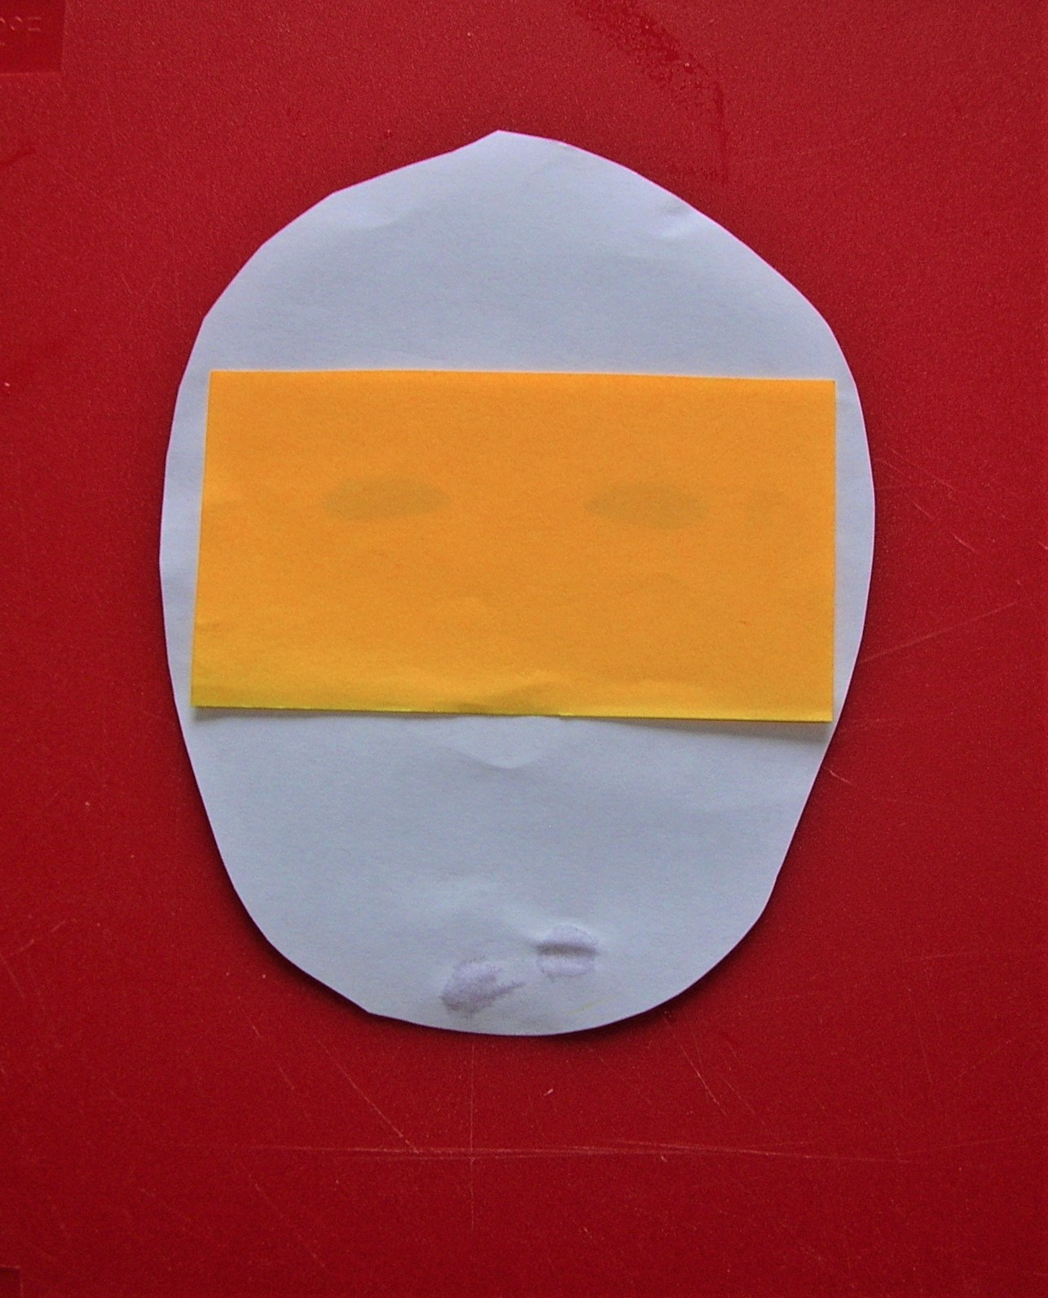
- Stick the small rectangle, so that the glued bites are close to the ears on both sides. I have used a different colour to show you where it goes.
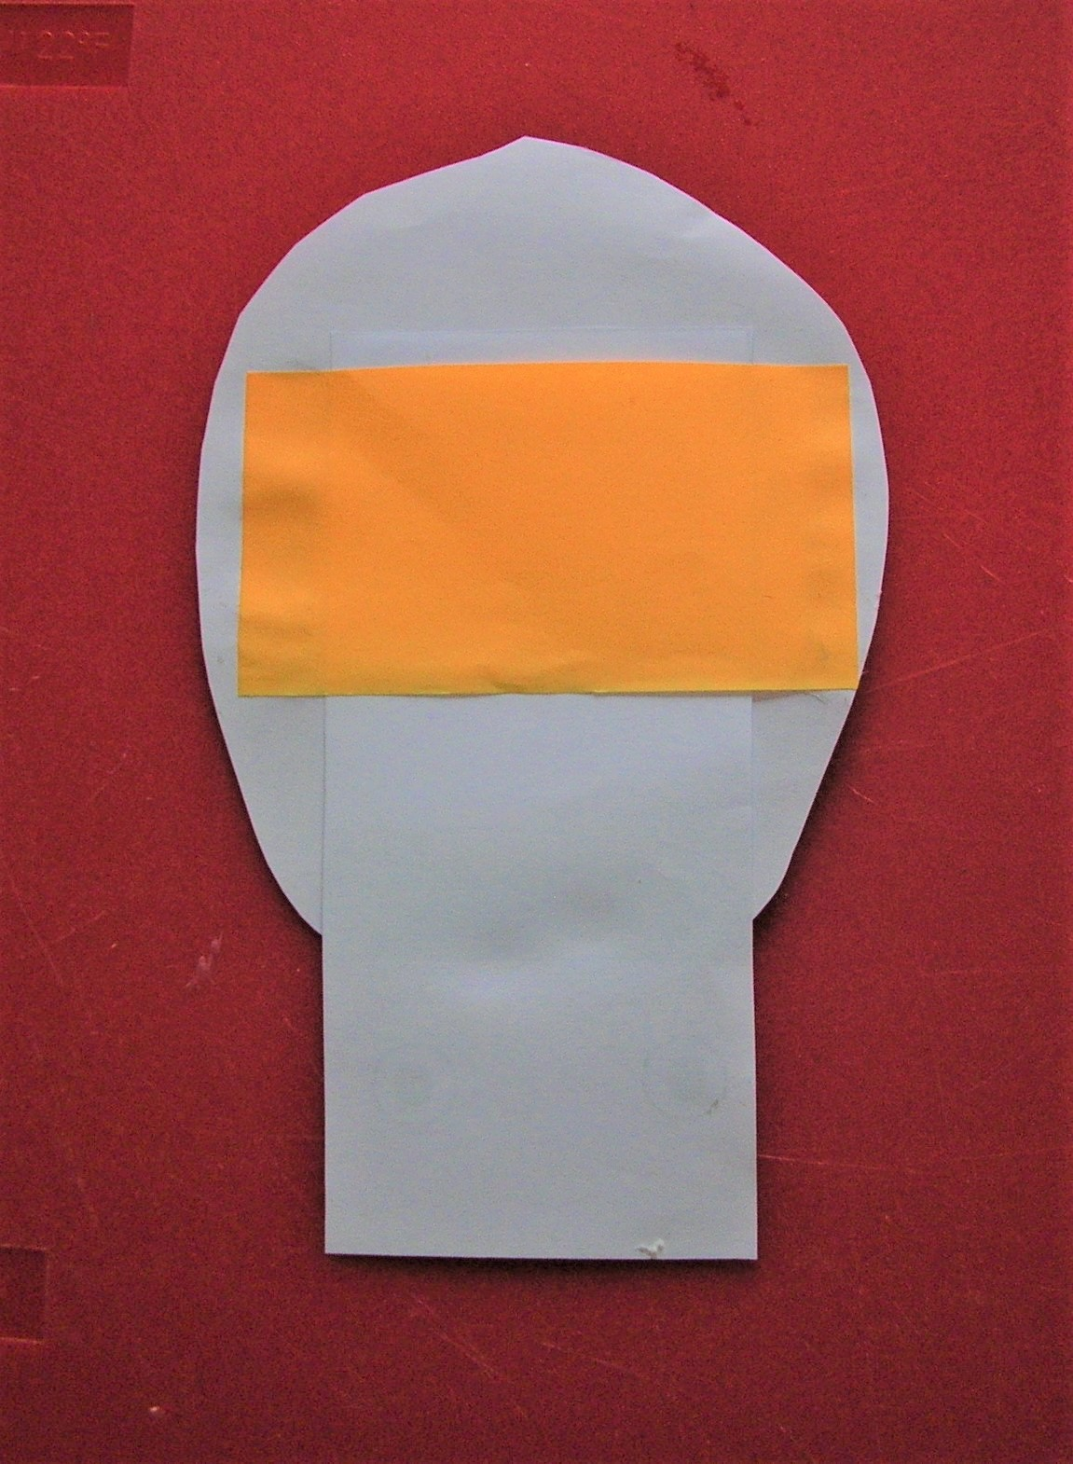
- Now take the long rectangle and place it so the writing is face downwards. Slide the card into the space between the face shape and the small rectangle.

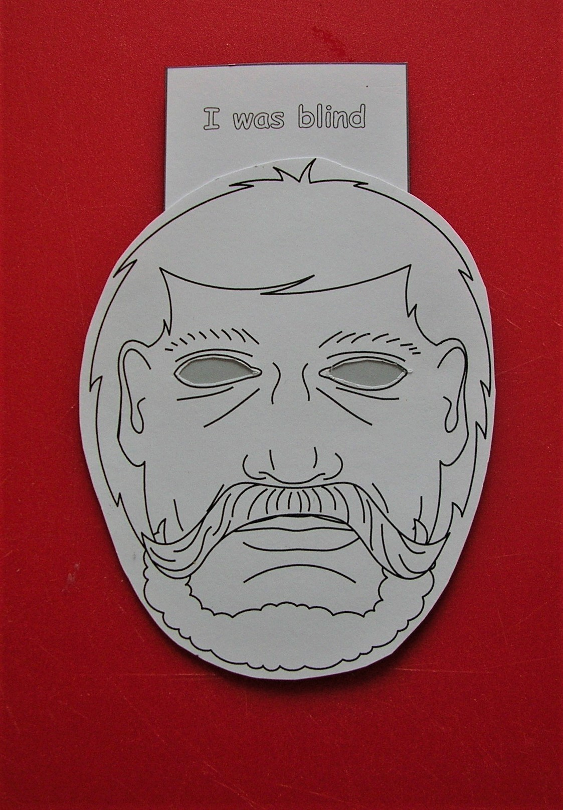
- Turn the shape over and slide the long rectangle further up so the grey area meets the eye holes.

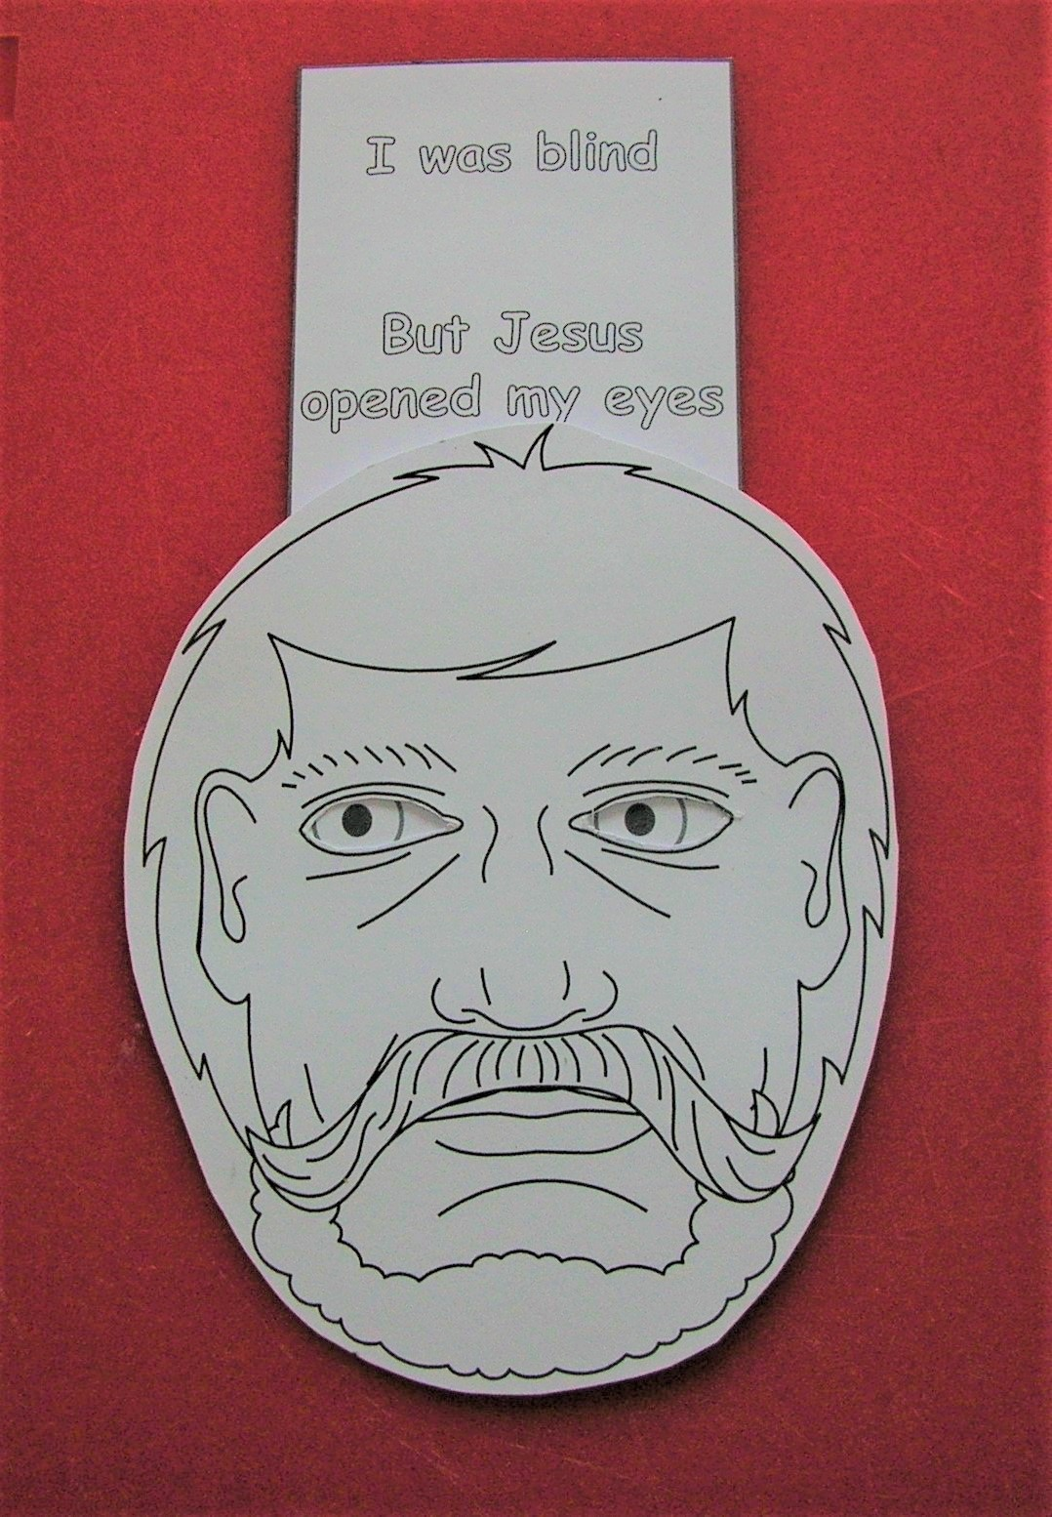

- Slide the rectangle a bit further so that the eyes are looking out.

- Why not colour in your face shape and the words on your rectangle card.

- Read the story again in John chapter 9 and change the face when Jesus heals the blind man.

