Easter Story – Word Ladder Activity
In this activity, you have to get from the bottom step of the ladder to the top step, changing one letter each time to make a new word.
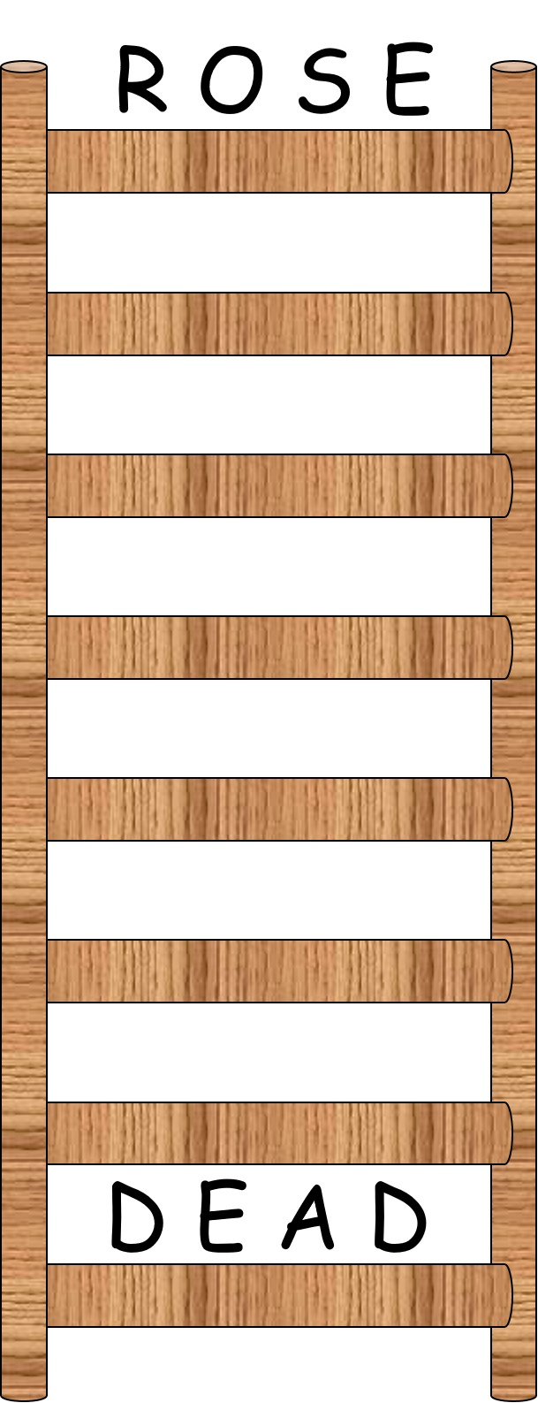
If you are struggling read John Chapter 19 verse 36.
It tells us no _ _ _ _ in Jesus’s body will be broken. This answer could go in step 5.

If you are really, REALLY struggling some solutions are given on the next page.

Possible solutions to the Word Ladder:
Dead, Bead, Bend, Bond, Bone, Lone, Lose, Rose
Dead, Lead, Lend, Land, Lane, Lone, Lose, Rose

