Colour this picture of the Israelites outside Jericho
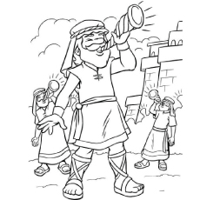

Original image http://getdrawings.com/joshua-coloring-pages

