Wedding at Cana – Finger Puppet craft activity

In this activity you will need:
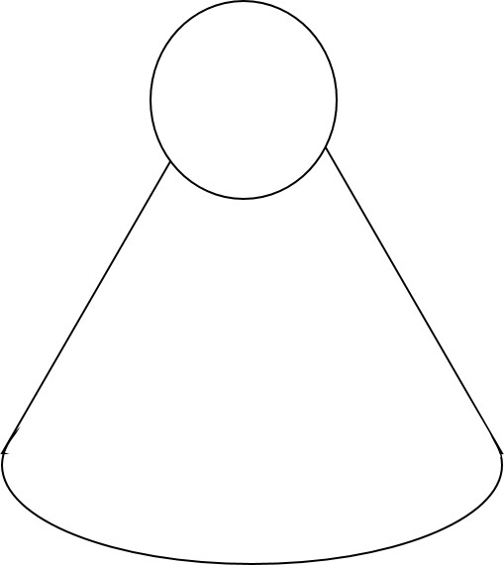
- Some paper
- Printed puppet pattern
- A pair of scissors
- Glue stick or Sellotape
- Coloured crayons
- A clever mum or dad to help you with the cutting out and to adapt the instructions if you need help.
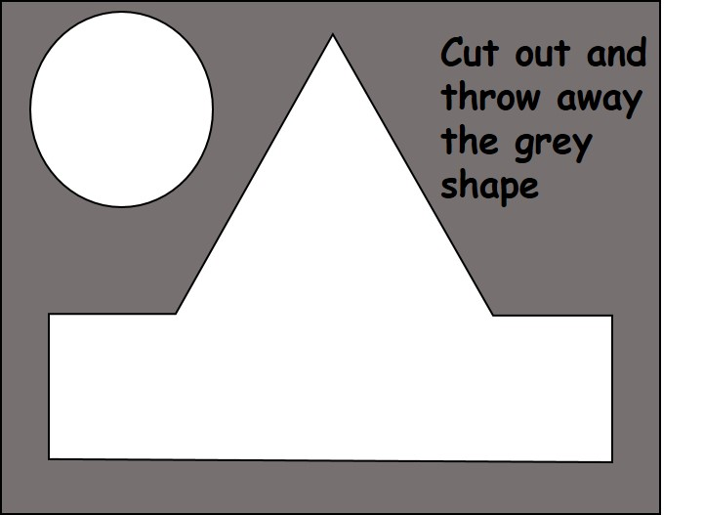

- Firstly, cut out the two shapes for each puppet.

- Next draw a face on the circle and a costume on the pointed shape.

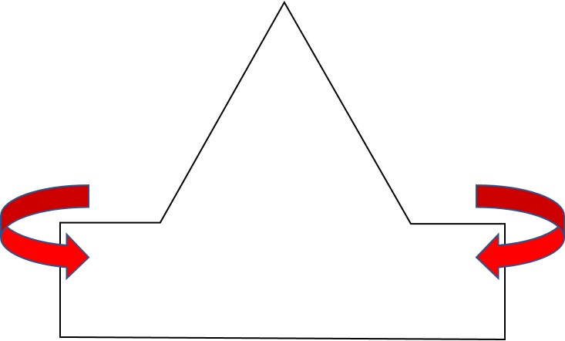

- Now fold the corner pieces around to make a cone shape. Remember to keep your drawing on the outside of the cone.

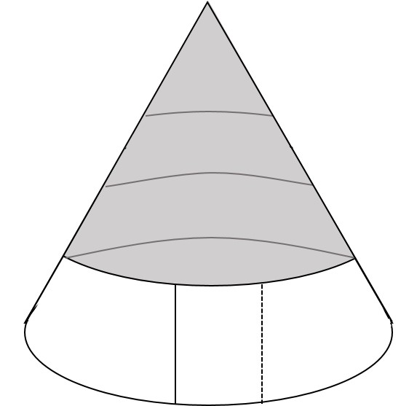
- Now stick the corners together so that the cone fits onto your finger. You will need to put one corner over the other corner.

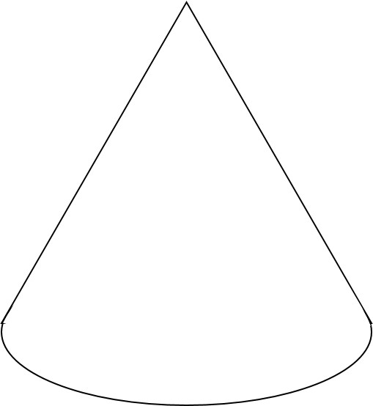

- Turn the cone around and stick your circle face onto the top part.

- You could make some more puppets and act out the Wedding at Cana story. You will need these puppets for the story: Jesus, Mary, the Bridegroom, a servant, Master of the feast, disciples.

You can find the Wedding at Cana story in your Bibles - John chapter 2 verses 1 – 11.

